Basic Spreadsheet Concepts Exercise 1
Type in the following spreadsheet, and format it to look like the sample below.
Instructions
1) Type in all text and numbers shown in the spreadsheet below.
2) Format all numbers as a currency.
3) Center the spreadsheet heading 'Sales and Produce Department' across the spreadsheet.
4) Format all text as displayed in the sample below.
5) Create formulas to display a total for each fruit.
6) Create formulas to display a total for each month.
7) Create a formula to calculate the total sales for all fruit items for the year to date

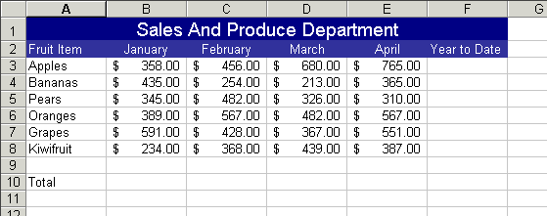

Basic Spreadsheet Concepts Exercise 2
Type in the following spreadsheet, and format it to look like the sample below.
Instructions
1) Type in all text and numbers shown in the spreadsheet below.
2) Format all numbers with appropriate format's).
3) Center the spreadsheet heading "Mike's Lunch Bar" across the spreadsheet.
4) Format all text as displayed in the sample below.
5) Create formula's to display a total for each item in the Lunch Bar.
6) Create a formula to calculate the total sales for the Lunch Bar.
7) Apply all borders and shading (colour) shown in the sample below, feel free to experiment with your own colour schemes

